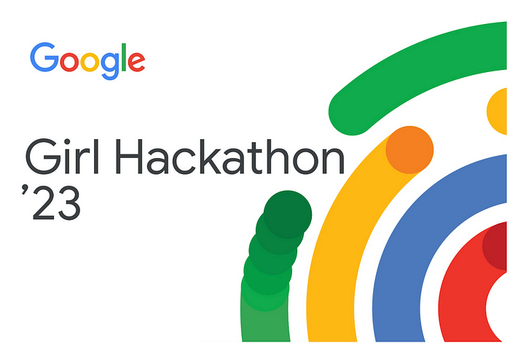

Live OA Problem Solving Session by :- Kumar K(SDE @ Amazon)

(World Rank 368 in Google Kickstart)

Starts at 6:30pm.

-> <https://www.linkedin.com/posts/kumark1_coding-google-amazon-activity-7071695279657222144-aJ-X?utm_source=share&utm_medium=member_desktop>

Requisite :->

Range Update Concept :-> You are given an array ; of all empty zeroes ; You are given Q queries. For each query ; you need to add “1” from [L,R] array ; print the final array after all queries are performed.

N = 5

[0 0 0 0 0]

Q -> {

1,5

3,5

}

Answer :-> [1 1 1 1 1] -> [1 1 2 2 2]

Brute Force(Pseudo Code) :-> <https://ideone.com/rQfqsU> O(N*Q)

Efficient :-> Prefix sum concept

Trick -> We set b[L] = 1 and b[R] = -1 for all the queries ; once all of that is done ; we run prefix sum algorithm on b array

Prefix_sum[i] = sum of all numbers from index 1 to i

TC : - O(N+Q)

C++ <https://ideone.com/hNy1fL>

Java <https://ideone.com/VEDLfd>

Python <https://ideone.com/U7L9Vr>

Problem :-> <https://www.desiqna.in/13650/google-girl-hackathon-coding-questions-solutions-2023-kumar>

Version 1 :-

1<=N<=100000

1<=K<=100000

100000>=A[i]>=K+1

Q : - You are given an array of size “N” ; in 1 operation you can change any A[i] to A[i] + x ; you can do these operations only 1 time on each index. Also x should lie in [-K,K] ; after doing all these operations ; pick up the largest possible set of equal numbers.

N = 3

[ 5 8 10] K = 2

—> [5(5+0) 8(8+0) 8(10-2) ]-----> 2 NUMBERS ARE EQUAL WHICH IS MAXIMUM POSSIBLE HENCE ANSWER IS 2.

N = 3

[5 8 10] K = 3

-> [8(5+3) 8(8+0) 8(10-2)]-> ALL 3 NUMBERS BECOME EQUAL WHICH IS THE MAXIMUM POSSIBLE.

VISUAlIZATION->

Pseudo - Code <https://ideone.com/L17BE1>

CPP <https://ideone.com/ChatXZ>

Java <https://ideone.com/hSyQ14>

Py <https://ideone.com/Sz5Kxn>

Version 2 :->

1<=N<=10000

1<=K<=100000000

-100000000<=A[i]<=100000000

(Super Interesting)

<https://ideone.com/NhmDu8>